**C#**

1**. Read and write line:**

Console.WriteLine("Please enter your name");

string UserName = Console.ReadLine();

Console.WriteLine("Hello " + UserName); //1st way Concatenate name with hello word and

Console.WriteLine("Hello {0}", UserName); //2nd way Placeholder syntax

2. **Terniry operator:**

int number=40;

string name=""

string data=number==40?"kumar":"noooooo";

Console.WriteLine("Myname is: {0}",data); // kumar

3. **Two types of C# types**

1. **Value types**: int,float,double,char,enum

* **By default value types are Notnullable we can make them nullable use ?**

a) nullable -> ex: bool? Result=null; ->its legal

b) not nullable-> ex: int num=null -> error

Null Coalescing Operator **??**

2. **Reference types**: class, array, interface , delegates.

**3. Lists:**

using System;

using System.Collections.Generic;

List<string> result=new List<string>(){"A","B","C"};

result.Add("D");

string[] data=new string[] {"E","F","G"};

//result.Remove("C");

//result.RemoveAt(2);

result.AddRange(data);

foreach(string res in result){

Console.WriteLine(res);

}

**4. Methods (static and instance):**

using System;

using System.Collections.Generic;

public class Hello

{

public static void Main(){

// calling instance methods we will create an instance for class

Hello res=new Hello();

res.Numbers();

// calling static method directly from class without create instance

Hello.Evenmum();

// calling instance methods with return type int

int sum = res.Add();

Console.WriteLine("SUM: {0}", sum);

// calling instance methods with parameters

res.Mul(20,30);

}

// instance method (doesn't have static keyword )

// void means doesn't return Anything

public void Numbers(){

for(int i=0;i<=5;i++){Console.WriteLine(i);

}

}

// static method (contains static keyword )

// static method with no return type

public static void Evenmum(){

for(int i=0;i<=5;i++){

if(i%2==0){

Console.WriteLine(i);

}

}

}

// method with return type (integer)

public int Add(){

int a=10;

int b=20;

return a+b;

}

// method type with parameters

public void Mul(int a,int b)

{

int mul=a*b;

Console.WriteLine(mul);

}

}

// output:

0 1 2 3 4 5

0 2 4

SUM: 30

600

**5. Method Parameters:**

There are 4 types of method parameters have

1. **Value parameters**: Create a copy of parameter passed. so modifications are not effect each other
2. **Reference parameters**: The ref method parameter keyword on a method parameter causes a method to refer to the same variable that was passed into the method. Any changes made to the parameter in the method will be reflected in that variable when control passes back to the falling method
3. **Out parameters**: use when you want a method to return more than one value
4. **Parameter arrays**: The parameter keyword lets you specify a method parameter that takes a variable number of arguments, you can send a comma separated list of arguments of an array on number of arguments, **params** keyword should be in the last one in the method declaration,

And only one **params** keyword is allowed in method declaration.

Method parameter:

**public static void ParamsMethod(int x,int y,int z);**

Method Argument:

**public static void ParamsMethod(1,2,3,4)**

1. **Value Parameters:**

using System;

public class Hello

{

public static void Main()

{

int i=0;

SimpleMethod(i); //without using reference key (1)

Console.WriteLine(i);//0 (not modified)

}

public static void SimpleMethod(int j){

j=200;

}

}

**output** : 0

**2.Reference parameters:**

using System;

public class Hello

{

public static void Main()

{

int i=0;

SimpleMethod(ref i); // using reference key (1)

Console.WriteLine(i); // 200 (modified)

}

public static void SimpleMethod(ref int j) { // using reference key (2)

j=200;

}

}

output : 200

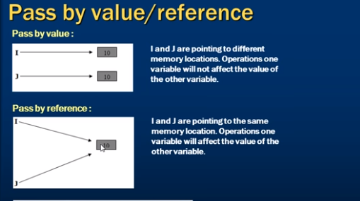

**3. Out parameters:**

using System;

public class Hello

{

public static void Main()

{

int a=10;

int b=30;

int Sum=0;

int Mul=0;

Calculate( a,b,out Sum ,out Mul);

Console.WriteLine("Sum: {0} ,Mul: {1}",Sum, Mul);

}

public static void Calculate(int fn,int sn,out int Sum,out int Mul){

Sum=fn+sn;

Mul=fn*sn;

}

}

output : Sum: 40 ,Mul: 300

1. **Parameter arrays**

public class Hello

{

public static void Main()

{

int[] records=new int[5];

records[0]=11; records[1]=22; records[2]=33; records[3]=44;records[4]=55;

ParamsMethod(records);

//ParamsMethod(1,2,3,4,5);

}

//public static void ParamsMethod(int x,params int[] records) // true

///*params must be only one and it should be last parameter*

//public static void ParamsMethod(params int[] records,int x) // *false*

public static void ParamsMethod(params int[] records){

Console.WriteLine(records.Length);

foreach(int result in records){

Console.Write( "{0} ", result);

}

}

}

output : 5

11 22 33 44 55

**6. Namespaces:**

1. Namespaces in C# are used to organize too many classes so that it can be easy to handle the application.

Ex: using System;

Using system is a “*namespace “* consists of class name called *“Console”.*

A namespace can contain:

1.Anothe namespace

2. class

3.interface

4.struct

5.enum

6.delegate

using System;

//using ProjectA.TeamA; // using Directive(step 1)

//using ProjectA.TeamB; // using Directive(step 1)

using PATA= ProjectA.TeamA; // using Directive with alias name

using PATB= ProjectA.TeamB;

public class Programm

{

public static void Main()

{

/// method1 -> Fully Qualified Name

// ProjectA.TeamA.ClassA.Print();

// ProjectA.TeamB.ClassA.Print();

/// method2 -> Using Directive (step2)

// ClassA.Print();

// ClassA.Print();

/// method3 -> Using Directive with Alias name called PATA. name space more length we will use this

PATA.ClassA.Print();

PATB.ClassA.Print();

}

}

namespace ProjectA{

namespace TeamA{

public class ClassA{

public static void Print(){

Console.WriteLine("We Are TEAM A");

}

}

}

}

namespace ProjectA{

namespace TeamB{

public class ClassA{

public static void Print(){

Console.WriteLine("We Are TEAM B");

}

}

}

}

**7. Class:**

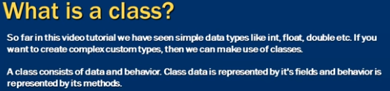

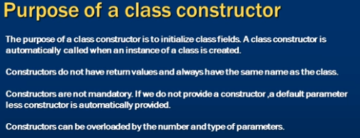

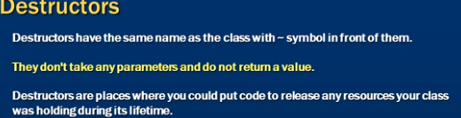

**Ex:**

using System;

public class Hello

{

public static void Main()

{

///constructor with no parameter (1)

Employee E1=new Employee();

E1.Fullname(); // o/p: FULL NAME IS No Fname No Lname

///constructor with parameter (2)

Employee E2=new Employee("kumar","swamy");

E2.Fullname(); //o/p: FULL NAME IS kumar swamy

///By E1 And E2 the Constructor is overloaded.

}

}

public class Employee{

string _fname;

string _lname;

// constructor with no parameter (1)

public Employee():this("No Fname","No Lname"){}

// constructor with parameter (2)

public Employee(string Firstname,string Lastname){

this._fname=Firstname; // “this” referes to an instance of a class (Employee)

this._lname=Lastname;

}

// instance method (without static keyword) to call this need to create instace(object)

public void Fullname(){

Console.WriteLine("FULL NAME IS {0}", this._fname + " " + this._lname );

}

/// destructor function

~Employee(){

// clean up code

}

}

**8. Static and instance class members:**

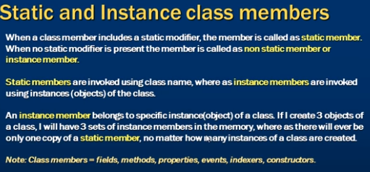

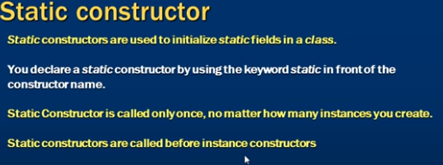

**9. Inheritance:**

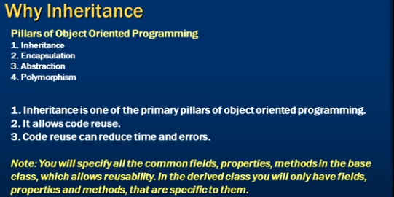

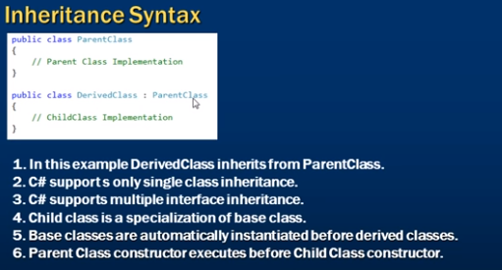

using System;

public class Hello

{

public static void Main()

{

// creating instace (object) for FullTimeEmp

FullTimeEmp FTE=new FullTimeEmp();

FTE._fname="kumar";

FTE._lname="swamy";

FTE._email="kumar10@gmail.com";

FTE._yearsal=400000;

FTE.GetFullName();

// creating instace (object) for PartTimeEmp

PartTimeEmp PTE=new PartTimeEmp();

PTE._fname="suresh";

PTE._lname="babu";

PTE._email="suresh10@gmail.com";

PTE._daysal=2000;

PTE.GetFullName();

}

}

/// Base Class

public class Employee{

public string _fname;

public string _lname;

public string _email;

public void GetFullName(){

Console.WriteLine("FULL NAME: {0} {1} ,Email: {2}" ,_fname, _lname,_email);

}

}

/// Derived class 1

/// FullTimeEmp class access the All properties of Employee class And FullTimeEmp class properties

public class FullTimeEmp : Employee // inheritance Syntax ( child class: parent class)

{

public int _yearsal;

}

/// Derived class 2

/// PartTimeEmp class access the All properties of Employee class And PartTimeEmp class properties

public class PartTimeEmp :Employee

{

public int _daysal;

}

output:

FULLNAME: kumar swamy ,Email: kumar10@gmail.com

FULLNAME: suresh babu ,Email: suresh10@gmail.com

Ex:2:

create object only for Child class -> ParentClass constructor is also called (first) along with child class constructor

using System;

public class Hello

{

public static void Main()

{ // create object only for Child class -> ParentClass constructor is also called (first) along with child class constructor

ChildClass CLS=new ChildClass();

}

}

/// Base Class

public class ParentClass{

// parameter less constroctor (1)

public ParentClass(){

Console.WriteLine("Parent Class Called");

}

// parameterised constructor (2)

public ParentClass(string Message){

Console.WriteLine("Parent Class paramererised constructor called");

}

}

public class ChildClass : ParentClass

{

/// parent class Have both parameter less constroctor(1) or parameterised constructor (2)

/// use either parameter less constroctor(1) or parameterised constructor (2)

// public ChildClass():base("Some paramer string") //(1) o/p: Parent Class paramererised constructor called

public ChildClass() //(2) Parent Class Called

{

Console.WriteLine("child Class Called");

}

}

output:

Parent Class Called

child Class Called

**10. Method Hiding:**

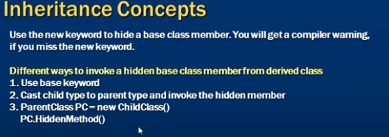

using System;

public class Programm

{

public static void Main()

{

FullTimeEmp FTE=new FullTimeEmp();

//Employee FTE=new FullTimeEmp(); // valid

//FullTimeEmp FTE=new Employee(); //invalid

FTE.print();

PartTimeEmp PTE=new PartTimeEmp();

}

}

public class Employee

{

public string fname="kumar";

public string lname="swamy";

public void print(){

Console.WriteLine("FULL NAME: {0} {1} ",fname, lname);

}

}

public class FullTimeEmp:Employee

{

// using new Keyword hide the parent class method and executes the following method

public new void print()

{

//// executes the base class method (Employee)

//base.print();

//o/p: FULL NAME: kumar swamy

Console.WriteLine("FULL NAME: {0} {1} - Fulltime Employee ",fname, lname);

//o/p: FULL NAME: kumar swamy - Fulltime Employee

}

}

public class PartTimeEmp:Employee

{

}

o/p: FULL NAME: kumar swamy - Fulltime Employee

**11. Polymorphism**

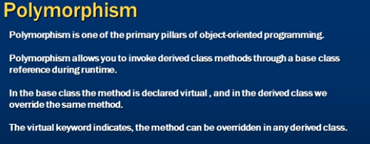

using System;

public class Programm

{

public static void Main()

{

Employee[] employees=new Employee[4];

employees[0]=new Employee();

employees[1]=new FullTimeEmp();

employees[2]=new PartTimeEmp();

employees[3]=new ContractEmp();

employees[3]=new NoEmp();

foreach(Employee e in employees ){

e.FullName();

}

}

}

public class Employee{

public string fname="kumar";

public string lname="swamy";

// virtual keyword used in parent class

public virtual void FullName(){

Console.WriteLine("FULL NAME : {0} {1}- Base class",fname,lname );

}

}

public class FullTimeEmp:Employee

{

// override keyword used in derived classes

Console.WriteLine("FULL NAME : {0} {1} -FULLTIME EMPLOYEE",fname,lname );

}

}

public class PartTimeEmp:Employee

{

public override void FullName(){

Console.WriteLine("FULL NAME : {0} {1} -PARTTIME EMPLOYEE",fname,lname);

}

}

public class ContractEmp:Employee

{

public override void FullName(){

Console.WriteLine("FULL NAME : {0} {1} - Contract EMPLOYEE",fname,lname);

}

}

// no override method takes Base class method

public class NoEmp:Employee

{

}

output:

FULL NAME : kumar swamy

FULL NAME : kumar swamy -FULLTIME EMPLOYEE

FULL NAME : kumar swamy -PARTTIME EMPLOYEE

FULL NAME : kumar swamy

**12. Difference between method overriding and method hiding**

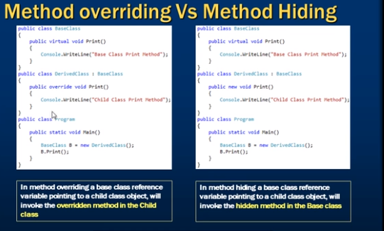

using System;

public class Programm

{

public static void Main()

{

BaseClass emp=new DerivedClass(); //o/p: FULL NAME : kumar swamy -Base class

// DerivedClass emp=new DerivedClass(); //o/p: FULL NAME : kumar swamy -Derived class

emp.FullName();

}

}

public class BaseClass{

public string fname="kumar";

public string lname="swamy";

public virtual void FullName(){

Console.WriteLine("FULL NAME : {0} {1}- Base class",fname,lname );

}

}

public class DerivedClass:BaseClass

{

public new void FullName(){

Console.WriteLine("FULL NAME : {0} {1} -Derived class",fname,lname );

}

}

**13.Method overloading:**

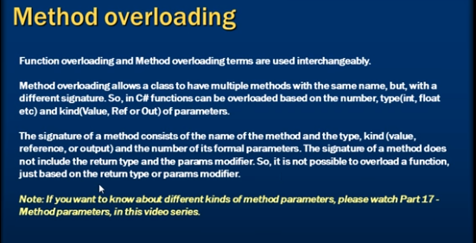

using System;

public class Programm

{

public static void Main()

{

Add(2,5);

//Add(2,5,5);

}

public static void Add(int a,int b)

{

Console.WriteLine("SUM:{0}",a+b);

}

///Method Overloading

public static void Add(float a, int b)

{

Console.WriteLine("SUM:{0}",a+b);

}

public static void Add(int a, int b,int c)

{

Console.WriteLine("SUM:{0}",a+b+c);

}

public static void Add(int a, int b,out int sum)

{

Console.WriteLine("SUM:{0}",a+b);

sum=a+b;

}

/// not overloaded possiple same method with different returntype

///compile time error

public static int Add(int a, int b)

{

Console.WriteLine("SUM:{0}",a+b);

return a+b;

}

/// not overloaded same no.of parameters and types

///compile time error

public static void Add(int a,int b)

{

Console.WriteLine("SUM:{0}",a+b);

}

}

**14. Why Properties:**

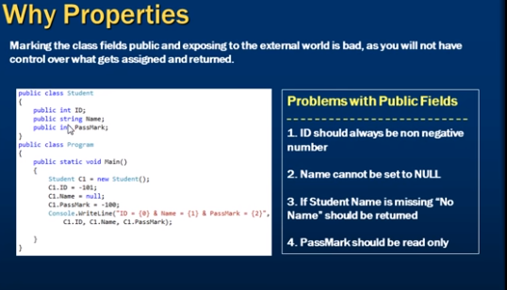

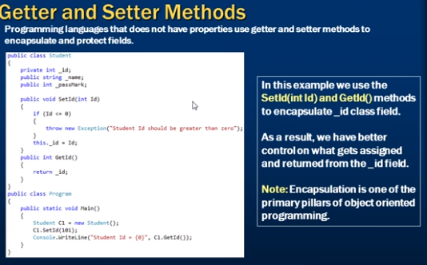

public class Programm

{

public static void Main()

{

Student std=new Student();

//std.SetId(-102); ///o/p: Unhandled Exception: System.Exception: ID Should be greater than ZERO

std.SetId(102);

// std.SetName(null); ///Unhandled Exception: System.Exception: name not be null or empty

std.SetName("kumar");

Console.WriteLine("DATA : id-{0},name-{1},passmark-{2}", std.GetId(), std.GetName(),std.GetPassmark());

}

}

public class Student{

private int _id;

private string _name;

private int _passmarks=35; //readonly (no setmethod)

public void SetId(int Id)

{

if(Id<=0){

throw new Exception("ID Should be greater than ZERO");

}

this._id=Id;

}

public int GetId(){

return _id;

}

public void SetName(string name){

if(string.IsNullOrEmpty(name)){

throw new Exception("name not be null or empty");

}

this._name=name;

}

public string GetName(){

return string.IsNullOrEmpty(this._name)?"No name":this._name;

}

public int GetPassmark(){

return this._passmarks;

}

}

0/p: DATA : id-102,name-kumar,passmark-35

**15.Properties in C#**

1. Read/Write Properties 2. Read Only Properties 3. Write Only Properties 4. Auto Implemented Properties

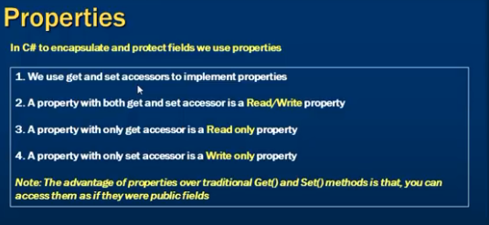



using System;

public class programm

{

public static void Main()

{

Student std=new Student();

std.Id=101;

std.Name="kumar";

Console.WriteLine("DATA: {0} -{1}-{2}",std.Id,std.Name,std.Passmark);

}

}

public class Student

{

private int _id;

private string _name;

private int _passmark=35;

private string _city;

public int Id

{

set{

if(value <= 0)

{

throw new Exception("id must me greaterthan zero");

}

this._id=value;

}

get{

return this._id;

}

}

public string Name

{

set{

if(string.IsNullOrEmpty(value)){

throw new Exception("name not be null or empty");

}

this._name=value;

}

get{

return this._name;

}

}

// readonly field

public int Passmark

{

get{

return this._passmark;

}

}

// optional fields

public string City

{

set;

get;

}

}

o/p: DATA: 101 -kumar-35

**16. classes vs structs:**

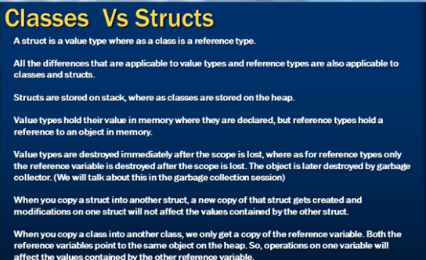

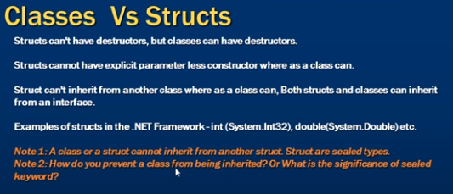

**17.interfaces:**

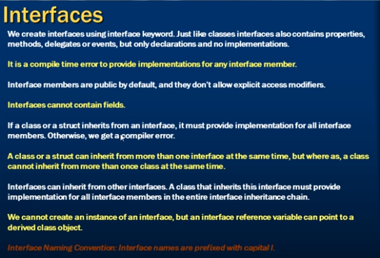

/// interfaces have only declarations

/// implementations are done by class only which is inherits that interfaces

using System;

interface Icustomer1{

/// error -> Interfaces cannot contain fields or constants

// int a=20; //false

/// error (The modifier `public' is not valid for this item Compilation failed: 1 error(s), 0 warnings)

/// dont use public here its by default public and it doesn't Allow Access modifiers.

//public void print1(); // false (compileerror)

void print1(); //true

///Note: void print1(); method must and should implemented by class

}

interface Icustomer2{

void print2();

}

/// An interface can implements another interface also possible

/* (2) secenario

interface Icustomer2:Icustomer1 //true

{

void print2();

}

*/

/// A class implements one or more interfaces at same time

public class Customer:Icustomer1,Icustomer2 //true

{

public void print1()

{

Console.WriteLine("This is Icustomer1 print1 method");

}

///if below method not implemented error ->`Customer' does not implement interface member `Icustomer2.print2()'

/// we must and should implement all methods available in interfaces for class(Customer)

public void print2()

{

Console.WriteLine("This is Icustomer1 print2 method");

}

}

public class Hello

{

public static void Main()

{

/// Cannot create an instance of the abstract class or interface `Icustomer1'.

//Icustomer1 cus1=new Icustomer1(); //false

// Icustomer1 cus1=new Customer(); /// (2) senario its true

Customer cus1=new Customer(); // true (instance for Class Custmoer)

cus1.print1();

cus1.print2();

}

}

output:

This is Icustomer1 print1 method

This is Icustomer1 print2 method

**18. Explicit interfaces implementation**

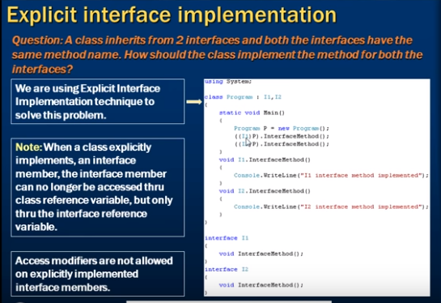

/// Both Interfaces are same method we can explicitly implement interface methods

using System;

interface Icustomer1{

void print();

}

interface Icustomer2{

void print(); // both interfaces have same method print();

}

public class Customer:Icustomer1,Icustomer2{

///The modifier `public' is not valid for this item

//public void Icustomer1.print() //false

void Icustomer1.print()

{

Console.WriteLine("PRINT 1 Method");

}

void Icustomer2.print() //false

{

Console.WriteLine("PRINT 2 Method");

}

}

public class programm

{

public static void Main()

{

Customer cst=new Customer();

// typcast operator ((Icustomer1)cst)

// cst.print(); // o/p:PRINT 1 Method ->(public void print(){})

((Icustomer1)cst).print(); //o/p:PRINT 1 Method

((Icustomer2)cst).print(); //o/p:PRINT 2 Method

}

}

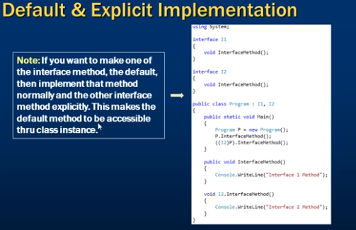

**19. Abstract classes**

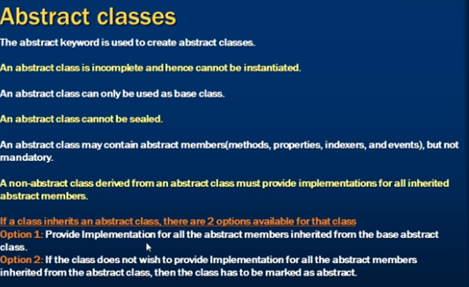

**Sealed**: means not be used as base class.

using System;

/// we can use abstract keyword for abstract class

public abstract class Customer{

// int a=20; //true

/// `Customer.print()' must have a body because it is not marked abstract, extern, or partial

//public void print(); //false

///`Customer.print()' cannot declare a body because it is marked abstract

//public abstract void print(){} //false

///secenario 1:

public abstract void print(); //true

///secenario:2

/*

public void print(){

Console.WriteLine("PRINT"); //o/p :print

} */

}

public class Programm : Customer

{

public static void Main()

{

Programm p=new Programm();

p.print(); //o/p: PRINT METHOD

}

///hides inherited member `Customer.print()'. To make the current member override that implementation

//public void print(){ //false

// /*

///secenario:1:

public override void print(){

Console.WriteLine("PRINT METHOD");

}

// */

}

**20. Difference between abstract classes and interfaces:**

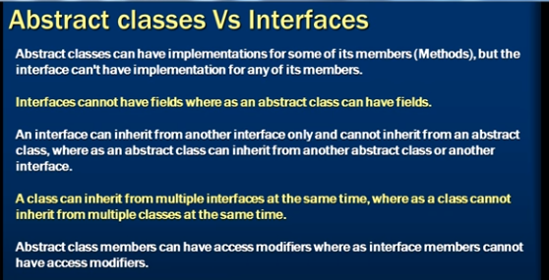

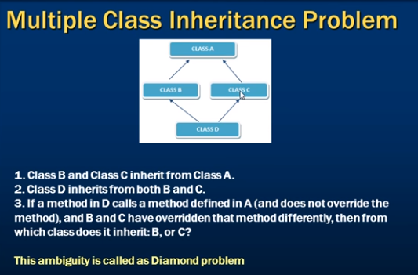

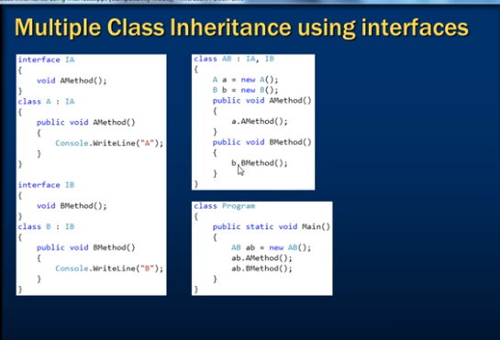

---------------------------------------****************----------------------------------------

**21. Delegates**

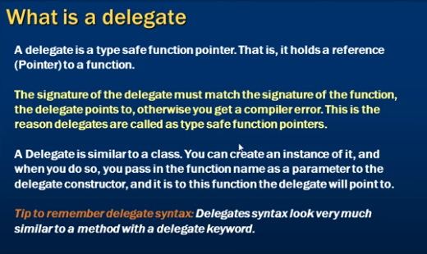

using System;

public class Hello

{

public delegate void Printfuncdelegate(string Message);

/// the signature of the delegate and function should be same

public static void Main()

{

//DEF: A Delegate is a type safe function pointer.

/// A delegate points to a function And then when you invoke this delegate the function will be invoked

/// Delegates is used for flexibility over the calling functions directly

Printfuncdelegate del=new Printfuncdelegate(Print);

del("this is message from delegate");

}

public static void Print(string message){

Console.WriteLine(message);

}

}

Output: this is message from delegate

**22.Exception Handling:**

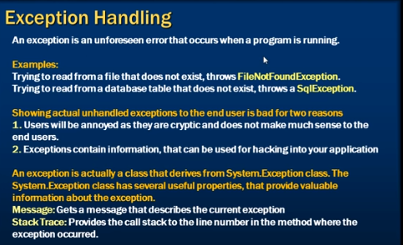

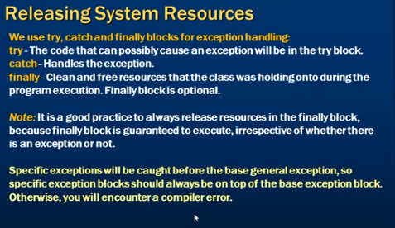

using System;

using System.IO; // for straemreader

class Program

{

static void Main(string[] args)

{

StreamReader strreader = null;

try

{

strreader = new StreamReader(@"C:\data\data1.txt");

Console.WriteLine(strreader.ReadToEnd());

//strreader.Close(); release resource

}

// Exception->SystemException->IOException->FileNotFoundException

// (Exception) is in using System namespace like Console.

catch (FileNotFoundException ex) // FileNotFoundException

{

//Console.WriteLine(ex.FileName); // ex.FileName Available in Child class (FileNotFoundException) it returns file name which is not found

//o/p: C:\data\data1.txt

/// if DirectoryNotFoundException occured thos block not executed.

Console.WriteLine("The file is not exist please check file: {0}", ex.FileName);

}

/*

catch (Exception ex) // catches the all exception (Always specify bottom of all catch blocks)

{

Console.WriteLine(ex.Message); // prints the exception message

Console.WriteLine(ex.StackTrace); // prints the exception messagene number

}

*/

finally {

// it is optional block.

/// if it specify it executes guarantee. so relaease resources in finally block

if(strreader!=null){

strreader.Close();

}

}

}

}

**23.Inner Expression:**

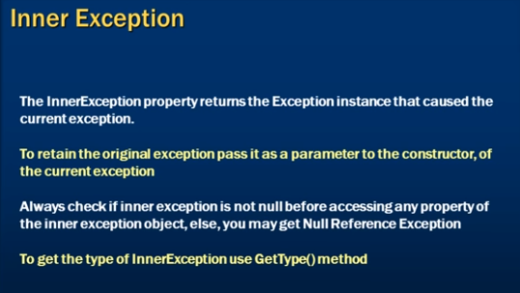

using System;

using System.IO; // for straemreader

class Program

{

static void Main(string[] args)

{

try

{

try

{

Console.WriteLine("Enter Firstnum");

int FN = Convert.ToInt32(Console.ReadLine());

Console.WriteLine("Enter Secondnum");

int SN = Convert.ToInt32(Console.ReadLine());

int result = FN / SN;

Console.WriteLine("Result: {0}", result);

}

catch (Exception ex)

{

string Filepath = @"C:\data\log1.txt";

if (File.Exists(Filepath))

{

StreamWriter str = new StreamWriter(Filepath);

str.Write(ex.GetType().Name);

str.WriteLine();

str.Write(ex.StackTrace);

str.WriteLine();

str.Write(ex.Message);

str.Close();

//Console.WriteLine(ex.Message);

}

else

{

throw new FileNotFoundException(Filepath + "File not found to write", ex); //passing expression parameter

}

}

}

catch (Exception Exception)

{

// if filr not found to write

Console.WriteLine("CURRENT EXCEPTION: {0}", Exception.GetType().Name);

if (Exception.InnerException != null)

{

Console.WriteLine("INNER EXCEPTION:{0}", Exception.InnerException.GetType().Name);

}

}

}

}

output:

Enter Firstnum

10

Enter Secondnum

0

CURRENT EXCEPTION: FileNotFoundException

INNER EXCEPTION:DivideByZeroException

Press any key to continue . . .

**24. Custom Exceptions:**

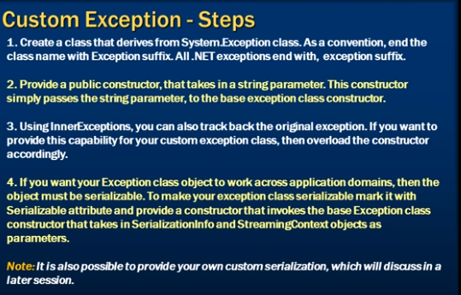

using System;

using System.Runtime.Serialization;

class Program

{

static void Main(string[] args)

{

try

{

throw new userloggeinException("User alteady loggedin no duplication logins not allowed");

}

catch (userloggeinException Ex) {

Console.WriteLine(Ex.Message);

}

}

}

///Serialization allows the developer to save the state of an object and recreate it as needed, providing storage of objects as well as data exchange.

///Through serialization, a developer can perform actions like sending the object to a remote application by means of a Web Service,

///passing an object from one domain to another, passing an object through a firewall as an XML string, or maintaining security or user-specific information across applications.

[Serializable]

public class userloggeinException : Exception

{

public userloggeinException():base()

{

}

public userloggeinException(string message) : base(message) // this one used

{

}

public userloggeinException(string message, Exception innerException) : base(message,innerException)

{

}

public userloggeinException(SerializationInfo info, StreamingContext context) : base(info, context)

{

}

}

Output: User alteady loggedin no duplication logins not allowed

**Enums:**

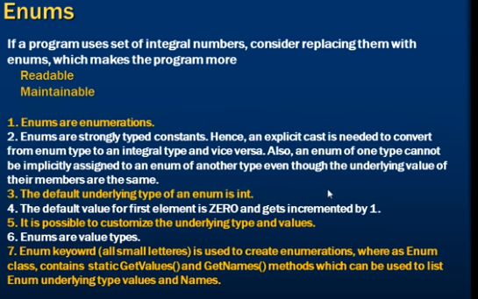

using System;

public class Program

{

  public static void Main()

  {

    Console.WriteLine(Enum.GetName(typeof(WeekDays), 4));

    Console.WriteLine("WeekDays constant names:");

    foreach (string str in Enum.GetNames(typeof(WeekDays)))

          Console.WriteLine(str);

    Console.WriteLine("Enum.TryParse():");

    WeekDays wdEnum;

    Enum.TryParse<WeekDays>("1", out wdEnum);

    Console.WriteLine(wdEnum);

  }

}

enum WeekDays

{

Monday,

Tuesday,

Wednesday,

Thursday,

Friday,

Saturday,

Sunday

}

1. String enum is not supported in C#.

**Generics:**

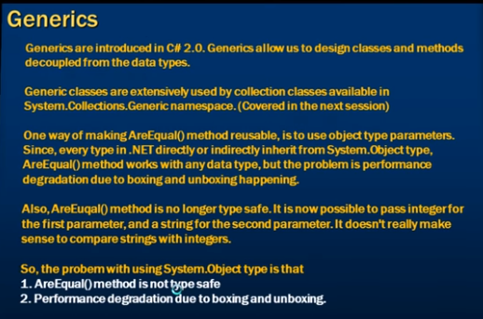

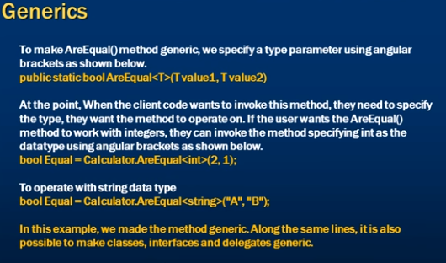

using System;

class Program

{

static void Main(string[] args)

{

/// without generic

//bool Equal= Compare.AreEqual(10, 10); (1) (2)

//bool Equal= Compare.AreEqual("A", "A"); (1) (2)

/// with generic

//bool Equal= Compare.AreEqual<int>(10, 10); //op: Equal (3)

bool Equal = Compare.AreEqual<string>("A", "B"); // op: Not Eqaul (3)

if (Equal)

{

Console.WriteLine("Eqaul");

}

else

{

Console.WriteLine("Not Eqaul");

}

}

}

public class Compare

{

/// here we can pass only integers are arguments without generics

/* public static bool AreEqual(int val1, int val2) { (1)

return val1 == val2;

}

*/

/// here we can use object but it degrade the performance .any type converts the object type because of every type comes from System.Object

/* public static bool AreEqual(object val1, object val2) { (2)

return val1 == val2;

}

*/

/// here we can pass any data type are arguments without generics

public static bool AreEqual<Type>(Type val1, Type val2) // (3)

{

return val1.Equals(val2);

}

}

**Why should you override ToString() Method:**

using System;

namespace TestPrg

{

class Program

{

static void Main(string[] args)

{

int Number = 10;

Console.WriteLine(Number.ToString()); //o/p:10

Customer C1 = new Customer();

C1.Fname = "kumar";

C1.Lname = "swamy";

//Console.WriteLine(C1.ToString()); // o/p : TestPrg.Customer (namespace.classname -> Before overriding ToStringmethod)

Console.WriteLine(C1.ToString()); // o/p : kumar swamy (After overriding ToStringmethod)

}

}

public class Customer

{

public string Fname { get; set; }

public string Lname { get; set; }

// to override string

public override string ToString() // (2)

{

//return base.ToString();

return this.Fname + " " + this.Lname;

}

}

}

**Why should you override Equals Method:**

using System;

namespace TestPrg

{

class Program

{

static void Main(string[] args)

{

// for Enum types

Directions direction1 = Directions.East; // (1)

Directions direction2 = Directions.West;

Console.WriteLine(direction1 == direction2);// false

Customer C1 = new Customer();

C1.Fname = "kumar";

C1.Fname = "swamy";

// Customer C2 = C1; //true

Customer C2 = new Customer();

C2.Fname = "kumar";

C2.Fname = "swamy";

Console.WriteLine(C1==C2); // false

Console.WriteLine(C1.Equals(C2)); // with out public override bool Equals(object obj) -> False

// with public override bool Equals(object obj) -> True (2)

}

}

public enum Directions { //(1)

East=1,

West,

North,

South

}

public class Customer

{

public string Fname { get; set; }

public string Lname { get; set; }

// to override Eqals

public override bool Equals(object obj) //(2)

{

//return base.Equals(obj);

if (obj == null) { return false; }

if (!(obj is Customer)) { return false; }

return this.Fname == ((Customer)obj).Fname && this.Lname == ((Customer)obj).Lname;

}

public override int GetHashCode()

{

//return base.GetHashCode();

return this.Fname.GetHashCode() ^ this.Lname.GetHashCode();

}

}

}

**Difference between Convert .ToString ()and ToString():**

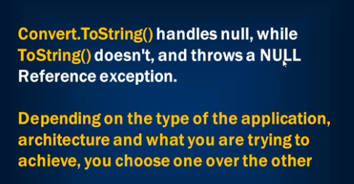

using System;

namespace TestPrg

{

class Program

{

static void Main(string[] args)

{

//Customer C1 = new Customer();

Customer C1 = null; // (1)

// Console.WriteLine(Convert.ToString(C1)); // output: empty string (1)

Console.WriteLine(C1.ToString()); //o/p:System.nullreference Exception (1)

}

}

public class Customer

{

public string Fname { get; set; }

public string Lname { get; set; }

}

}

**Difference between String and StringBuilder**

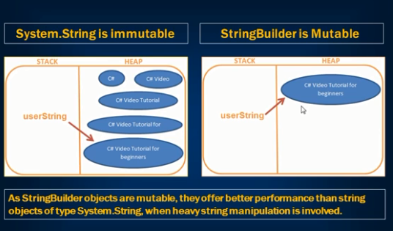

using System;

using System.Text; //For StringBuilder

class Program

{

static void Main(string[] args)

{

/// using strings creates objects for every adding data (immutable)

string userdata = "name: kumar";

userdata += "email: xxx@gmail.com";

userdata += "mobile: 12312324";

Console.WriteLine(userdata);

// using StringBuilder (mutable) -creates only one object in same object it overrides

StringBuilder userstring = new StringBuilder("name: kumar");

userstring.Append("email: xxx@gmail.com");

userstring.Append("mobile: 12312324");

Console.WriteLine(userstring);

}

}

**Dictionays:**

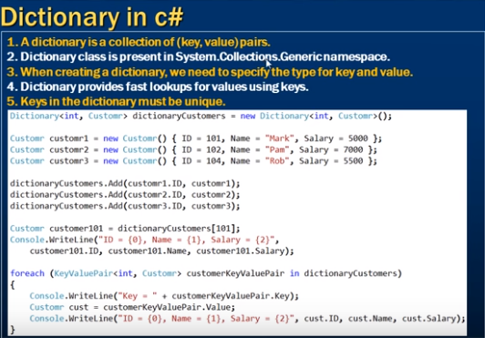

//Dictionary

using System;

using System.Collections.Generic; // For Dictionary

class Program

{

static void Main(string[] args)

{

/// create instance for Customer Object

Customer Customer1 = new Customer()

{id=1,name="kumar", age=27,salary=20000};

Customer Customer2 = new Customer()

{id = 2, name = "suresh", age = 28, salary = 30000 };

Customer Customer3 = new Customer()

{id = 3, name = "rajesh", age = 26, salary = 50000 };

///Creating A Dictionary

/// syntax: Dictionary<keytype, Valuetype> Dictionaryvariable = new Dictionary<keytype, Valuetype>();

// Example:

//Dictionary<string, string> names = new Dictionary<string, string>();

//names.Add("1", "Sonoo");

Dictionary<int, Customer> Dictvar = new Dictionary<int, Customer>();

/// Add Data to Dictionary

Dictvar.Add(Customer1.id, Customer1);

Dictvar.Add(Customer2.id, Customer2);

Dictvar.Add(Customer3.id, Customer3);

/// keys must be unique we can't add "Customer3.id" again it throws exception an item with same key already exist

// Dictvar.Add(Customer3.id, Customer3);

/// checking if key is already exist or not

if (!Dictvar.ContainsKey(Customer3.id))

{

Dictvar.Add(Customer3.id, Customer3);

}

/// if key not availabel it throws keynot found Exception

//Customer Dictvarkey6 = Dictvar[6];

if (Dictvar.ContainsKey(6))

{

Customer Dictvarkey6 = Dictvar[6];

}

Customer Dictvarkey = Dictvar[2]; // 2 is the key to get info based on key

Console.WriteLine("for key 2: id:{0}-name:{1}-age{2}-salary{3}", Dictvarkey.id, Dictvarkey.name, Dictvarkey.age, Dictvarkey.salary);

// o/p: id:2-name:suresh-age28-salary30000

// foreach (var allcustomers in Dictvar) // var is also correct insted of KeyValuePair<int, Customer>

foreach (KeyValuePair<int,Customer> allcustomers in Dictvar) {

Console.WriteLine(allcustomers.Key); //o/p: 1 2 3

Console.WriteLine(allcustomers.Value);// Customer Customer Customer

Customer cust=allcustomers.Value;

Console.WriteLine("id:{0}-name:{1}-age:{2}-salary:{3}", cust.id, cust.name, cust.age,cust.salary);

/*output:

id:1-name:kumar-age:27-salary:20000

id:2-name:suresh-age:28-salary:30000

id:3-name:rajesh-age:26-salary:50000

*/

}

/// to get only keys

foreach (int key in Dictvar.Keys)

{

Console.WriteLine(key); //o/p: 1 2 3

}

/// to get only values

foreach (Customer cust in Dictvar.Values)

{

Console.WriteLine("id:{0}-name:{1}-age:{2}-salary:{3}", cust.id, cust.name, cust.age, cust.salary);

/*output:

id:1-name:kumar-age:27-salary:20000

id:2-name:suresh-age:28-salary:30000

id:3-name:rajesh-age:26-salary:50000

*/

}

}

}

public class Customer

{

public int id {get; set;}

public string name {get; set;}

public int age {get; set;}

public int salary{get; set;}

}

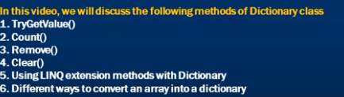

//Dictionary

using System;

using System.Collections.Generic; // For Dictionary

using System.Linq; // for Count()

class Program

{

static void Main(string[] args)

{

Customer Customer1 = new Customer()

{ id = 1, name = "kumar", age = 27, salary = 20000 };

Customer Customer2 = new Customer()

{ id = 2, name = "suresh", age = 28, salary = 30000 };

Customer Customer3 = new Customer()

{ id = 3, name = "rajesh", age = 26, salary = 50000 };

Dictionary<int, Customer> Dictvar = new Dictionary<int, Customer>();

Dictvar.Add(Customer1.id, Customer1);

Dictvar.Add(Customer2.id, Customer2);

Dictvar.Add(Customer3.id, Customer3);

/// Count method:

Console.WriteLine("Total Records:{0}", Dictvar.Count); // Total Records:3

// Count() avialble in using System.Linq; name space

Console.WriteLine("Total Records:{0}", Dictvar.Count()); // Total Records:3 (without parameter )

Console.WriteLine("Total Records:{0}", Dictvar.Count(res => res.Value.salary > 25000)); // Total Records:2 (with parameter )

/// TryGetValue

Customer cust;

if (Dictvar.TryGetValue(1, out cust))

{

Console.WriteLine("id:{0}-name:{1}-age{2}-salary{3}", cust.id, cust.name, cust.age, cust.salary);

}

else

{

Console.WriteLine("key not Found");

}

///Remove() syntax: Dictvar.Remove(key);

//Dictvar.Remove(1); // if key not avialble nothing happen

/// to remove all keys and values from distionary we use

//Dictvar.Clear();

// Convert An Array into A Dictionary

/* Customer[] Arraydata = new Customer[3];

Arraydata[0] = Customer1;

Arraydata[1] = Customer2;

Arraydata[2] = Customer3;

Dictionary<int, Customer> dictdata = Arraydata.ToDictionary(data => data.id, data=>data);

foreach (KeyValuePair<int, Customer> allcustomers in dictdata)

{

Customer custr = allcustomers.Value;

Console.WriteLine("id:{0}-name:{1}-age:{2}-salary:{3}", custr.id, custr.name, custr.age, custr.salary);

}

*/

}

}

public class Customer

{

public int id {get; set;}

public string name {get; set;}

public int age {get; set;}

public int salary{get; set;}

}

**Lists<>:**

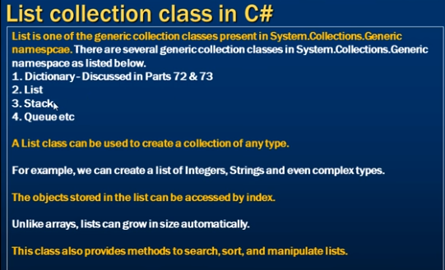

//Lists

using System;

using System.Collections.Generic; // For list

class Program

{

static void Main(string[] args)

{

Customer Customer1 = new Customer()

{ id = 1, name = "kumar", age = 27, salary = 20000 };

Customer Customer2 = new Customer()

{ id = 2, name = "suresh", age = 28, salary = 30000 };

Customer Customer3 = new Customer()

{ id = 3, name = "rajesh", age = 26, salary = 50000 };

/// Creating List

/// List size increases Automatically. but array size is not increased it fixed size.

// List<Customer> Customers = new List<Customer>(2); intial size we can add more possible

List<Customer> Customers = new List<Customer>(); // "Customer" is complex type

Customers.Add(Customer1);

Customers.Add(Customer2);

Customers.Add(Customer3);

// Customers.Add(200); // compile error we can add same type only

/// we can chane index position

Customers.Insert(0,Customer3); // Customer3 is at in '0' and '3' position

/// we can find index position of Customer3

Console.WriteLine(Customers.IndexOf(Customer3)); //o/p: 0

/// we can find index position of Customer3 from 1 st postion

Console.WriteLine(Customers.IndexOf(Customer3,1)); //o/p: 3

/// we can find index position of Customer3 from 1 st postion to n positions

Console.WriteLine(Customers.IndexOf(Customer3, 1, 2)); //o/p: -1 (not found)

Console.WriteLine(Customers.IndexOf(Customer3, 1, 3)); //o/p: 3

// Console.WriteLine(Customers.IndexOf(Customer3, 1, 4)); //o/p: ArgumentOutOfRangeException

///(1) using foreach loop

foreach (Customer cust in Customers) {

Console.WriteLine("Customers{0} : id:{0},name:{1},age:{2}", cust.id,cust.name,cust.age);

}

/* o/p:

Customers: id: 1,name: kumar,age: 27

Customers: id: 2,name: suresh,age: 28

Customers: id: 3,name: rajesh,age: 26 */

///(2) using for loop

/// suppose count is excedded then we gat "ArgumentOutofRangeException" so better use of foreach loop

// for (int i = 0; i <= Customers.Count; i++) "ArgumentOutofRangeException"

for (int i = 0; i < Customers.Count; i++)

{

Customer cusdata = Customers[i];

Console.WriteLine("Customers{0} : id:{0},name:{1},age:{2}", cusdata.id, cusdata.name, cusdata.age);

}

/// we can add derived classes is also possible (4)

SubCustomer subcst = new SubCustomer();

Customers.Add(subcst); /// its possible

}

}

public class Customer

{

public int id {get; set;}

public string name {get; set;}

public int age {get; set;}

public int salary{get; set;}

}

public class SubCustomer: Customer //(4)

{

}

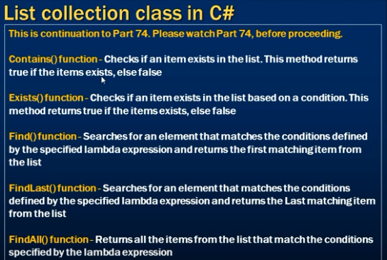

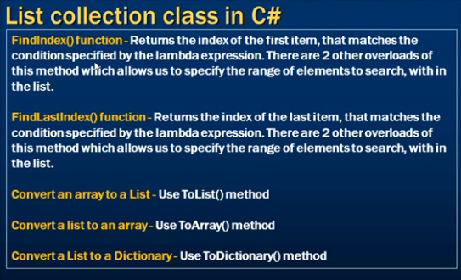

//List methods

using System;

using System.Collections.Generic; // For list

class Program

{

static void Main(string[] args)

{

Customer Customer1 = new Customer()

{ id = 1, name = "kumar", age = 27, salary = 20000 };

Customer Customer2 = new Customer()

{ id = 2, name = "suresh", age = 28, salary = 30000 };

Customer Customer3 = new Customer()

{ id = 3, name = "rajesh", age = 26, salary = 50000 };

List<Customer> Customers = new List<Customer>();

Customers.Add(Customer1);

Customers.Add(Customer2);

Customers.Add(Customer3);

/// (1) Contains(); it returns true or false return type bool

if (Customers.Contains(Customer3))

{

Console.WriteLine("Customer3 found"); //o/p: Customer3 found

}

else

{

Console.WriteLine("Customer3 Not found");

}

/// (2) Exists(); it returns true or false return type bool it is 'predicate' means use 'lamda function'

// if (Customers.Exists(cust => cust.name.startWith("s")))

if (Customers.Exists(cust => cust.age>26))

{

Console.WriteLine("Customer found"); //o/p: Customer found

}

else

{

Console.WriteLine("Customer Not found");

}

/// (3) Find(); it returns first matching Element

Customer c = Customers.Find(cust=>cust.salary> 20000);

Console.WriteLine("Result: {0}",c.name); //o/p: Result : suresh

/// (4) FindLast(); it returns last matching Element

Customer l = Customers.FindLast(cust => cust.salary > 20000);

Console.WriteLine("Result: {0}", l.name); //o/p: Result : rajesh

/// (5) FindAll(); it returns All matching Elements

List<Customer> allcust = Customers.FindAll(cust => cust.salary > 20000);

foreach(Customer cst in allcust){

Console.Write("id: {0} - name: {1} - sal: {2}", cst.id, cst.name, cst.salary);

// o/p: id: 2 - name: suresh - sal: 30000 id: 3 - name: rajesh - sal: 50000

}

/// (6) FindIndex(); it returns first index matching position

int index = Customers.FindIndex(cust => cust.salary > 20000);

Console.WriteLine("Index: {0}", index); //o/p: Index:1

int index2 = Customers.FindIndex(2 , cust => cust.salary > 20000);

Console.WriteLine("Index2: {0}", index2); //o/p: Index:2

/// (7) FindLastIndex(); it returns last index matching position

int lindex = Customers.FindLastIndex(cust => cust.salary > 20000);

Console.WriteLine("Index: {0}", lindex); //o/p: Index:2

}

}

public class Customer

{

public int id {get; set;}

public string name {get; set;}

public int age {get; set;}

public int salary{get; set;}

}

**All Convertions(list ,array,dictionary)**

//List convertions

using System;

using System.Collections.Generic; // For list

using System.Linq; // for tolist,todictionary

public class Program

{

static void Main(string[] args)

{

Customer Customer1 = new Customer()

{ id = 1, name = "kumar", age = 27, salary = 20000 };

Customer Customer2 = new Customer()

{ id = 2, name = "suresh", age = 28, salary = 30000 };

Customer Customer3 = new Customer()

{ id = 3, name = "rajesh", age = 26, salary = 50000 };

/// Converstions

/// (1) From List to Array

List<Customer> listCustomers = new List<Customer>();

listCustomers.Add(Customer1);

listCustomers.Add(Customer2);

listCustomers.Add(Customer3);

listCustomers.ToArray();

foreach (Customer cust in listCustomers) {

Console.WriteLine("Customers{0} : id:{0},name:{1},age:{2}", cust.id, cust.name, cust.age);

}

/// (2) From List to Distionary

Dictionary<int, Customer> dis = listCustomers.ToDictionary(X => X.id);

foreach (KeyValuePair<int,Customer> cust in dis)

{

Customer c = cust.Value;

Console.WriteLine("Customers{0} : id:{0},name:{1},age:{2}", c.id, c.name, c.age);

}

/// (3) From Array to list

Customer[] Customerarray = new Customer[3];

Customerarray[0] = Customer1;

Customerarray[1] = Customer2;

Customerarray[2] = Customer3;

List<Customer> CustList= Customerarray.ToList();

foreach (Customer cust in Customerarray)

{

Console.WriteLine("Customers{0} : id:{0},name:{1},age:{2}", cust.id, cust.name, cust.age);

}

}

}

public class Customer

{

public int id { get; set; }

public string name { get; set; }

public int age { get; set; }

public int salary { get; set; }

}

**Listranges:**

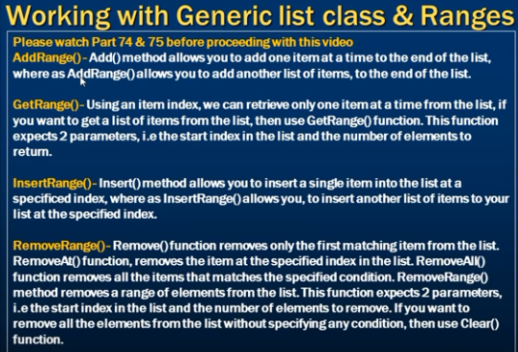

//List Ranges

using System;

using System.Collections.Generic; // For list

using System.Linq; // for tolist,todictionary

public class Program

{

static void Main(string[] args)

{

Customer Customer1 = new Customer()

{id=1, name="kumar", age=27, salary=25000,type="Active Customer"};

Customer Customer2 = new Customer()

{ id =2, name = "rajesh", age = 26, salary = 35000, type = "Active Customer" };

Customer Customer3 = new Customer()

{ id =3, name = "suresh", age = 23, salary = 55000, type = "Active Customer" };

Customer Customer4 = new Customer()

{ id =4, name = "vinod", age = 29, salary = 45000, type = "Pending Customer" };

Customer Customer5 = new Customer()

{ id =5, name = "murali", age = 28, salary = 60000, type = "Pending Customer" };

List<Customer> Customers = new List<Customer>();

Customers.Add(Customer1);

Customers.Add(Customer2);

Customers.Add(Customer3);

List<Customer> PendingCustomers = new List<Customer>();

PendingCustomers.Add(Customer4);

PendingCustomers.Add(Customer5);

///(1)AddRange()- we can add list to another list

Customers.AddRange(PendingCustomers);

/* foreach (Customer curcust in Customers)

{

Console.WriteLine("All Customers: id:{0}-name:{1}-age:{2},salary:{3}", curcust.id, curcust.name, curcust.age, curcust.salary,curcust.type);

}

*/

///(2)GetRange()- we can get list from one position to onother position (count)

// List<Customer> RangeCustomers =Customers.GetRange(0,5); // 0-starting pos ,5-total count (for totla records)

List<Customer> RangeCustomers =Customers.GetRange(1,3); // 1-starting pos ,3-total count

/* foreach (Customer curcust in RangeCustomers)

{

Console.WriteLine("Range Customers: id:{0}-name:{1}-age:{2},salary:{3}", curcust.id, curcust.name, curcust.age, curcust.salary,curcust.type);

} */

///(3)InsertRange()- we can insert data into top or middle by using index position

Customers.InsertRange(0,PendingCustomers); //PendingCustomers are inserted at index position 0

////(3)RemoveRange()- we can Remove data from one position to onother position

// Customers.RemoveRange(0, 3); // remove 3 items from 0 position

// Customers.RemoveAt(3); //remove 3 item at 3(index) position

// Customers.RemoveAll(X => X.type == "PendingCustomers"); //remove item based on condition type=...

// Customers.Clear(); // remove all items in list "Customers"

/* foreach (Customer curcust in Customers)

{

Console.WriteLine("All Customers: id:{0}-name:{1}-age:{2},salary:{3}", curcust.id, curcust.name, curcust.age, curcust.salary,curcust.type);

}

*/

/* foreach (Customer curcust in Customers)

{

Console.WriteLine("Active Customers: id:{0}-name:{1}-age:{2},salary:{3}", curcust.id, curcust.name, curcust.age, curcust.salary,curcust.type);

}

*/

/* foreach (Customer pencust in PendingCustomers)

{

Console.WriteLine("Pending Customers: id:{0}-name:{1}-age:{2},salary:{3}", pencust.id, pencust.name, pencust.age, pencust.salary,pencust.type);

}

*/

}

}

public class Customer

{

public int id { get; set; }

public string name { get; set; }

public int age { get; set; }

public int salary { get; set; }

public string type { get; set; }

}

**List sorting Simple types**

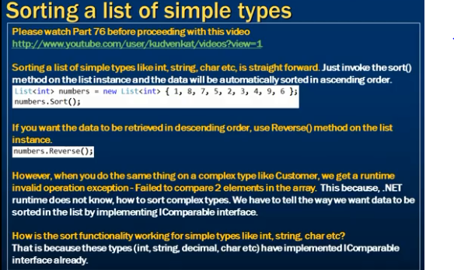

//List Sorting functions for simple types(int,string..)

using System;

using System.Collections.Generic; // For list

using System.Linq; // for tolist,todictionary

public class Program

{

static void Main(string[] args)

{

/// sorting numbers

List<int> Numbers = new List<int>(){ 8, 4, 6, 7, 0, 9, 2, 5 };

/// sort Assending oreder

Numbers.Sort(); // 0 2 4 5 6 7 8 9

//Numbers.Reverse(); // 5 2 9 0 7 6 4 8

foreach (int number in Numbers) {

Console.Write(number + " ");

// o/P: 0 2 4 5 6 7 8 9

}

//Numbers.Reverse(); // 9 8 7 6 5 4 2 0

/// sorting Strings

List<string> Strings = new List<string>() {"L","S","K","A","F","M","D"};

Strings.Sort();

foreach (string String in Strings)

{

Console.Write(String + " ");

// o/P: A D F K L M S

}

Strings.Reverse();

foreach (string String in Strings)

{

Console.Write(String + " ");

// o/P: S M L K F D A

}

}

}

**List sorting Complex types**

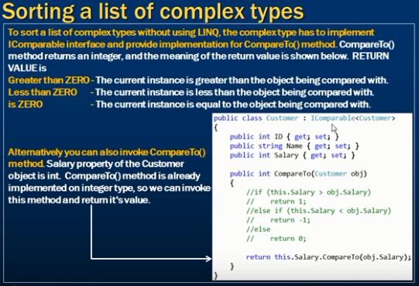

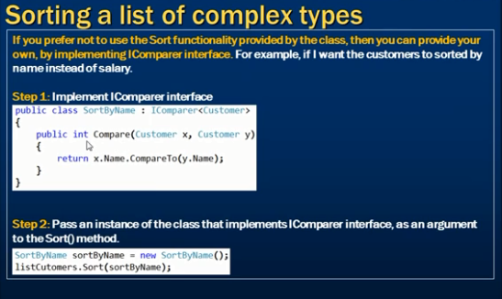

//List complex type sorting

using System;

using System.Collections.Generic; // For list

using System.Linq;

class Program

{

static void Main(string[] args)

{

Customer Customer1 = new Customer()

{ id = 1, name = "kumar", age = 27, salary = 20000 };

Customer Customer2 = new Customer()

{ id = 2, name = "suresh", age = 28, salary = 10000 };

Customer Customer3 = new Customer()

{ id = 3, name = "rajesh", age = 26, salary = 50000 };

List<Customer> Customers = new List<Customer>(); //"Customer" is complex type

Customers.Add(Customer1);

Customers.Add(Customer2);

Customers.Add(Customer3);

Customers.Sort();

foreach (Customer c in Customers)

{

// Console.WriteLine(c.name);

// Console.WriteLine(c.salary);

Console.WriteLine(c.age);

}

// (2) method (userdefined method)

SortBydata SortBydata = new SortBydata();

Customers.Sort(SortBydata);

foreach (Customer c in Customers)

{

Console.WriteLine(c.name);

//Console.WriteLine(c.salary);

//Console.WriteLine(c.age);

}

/// (3) method - using deligates

Customers.Sort(delegate (Customer c1, Customer c2)

{

return (c1.id.CompareTo(c2.id));

});

foreach (Customer c in Customers)

{

Console.WriteLine("using Deligate"+ c.name);

//Console.WriteLine(c.salary);

//Console.WriteLine(c.age);

}

/// (4) method - using lamda function (simplest method)

Customers.Sort((x,y) => x.id.CompareTo(y.id));

foreach (Customer c in Customers)

{

Console.WriteLine("using lamda expressions" + c.name);

//Console.WriteLine(c.salary);

//Console.WriteLine(c.age);

}

}

}

public class Customer : IComparable<Customer> //(1) method : IComparable is an built-in interface

{

public int id { get; set; }

public string name { get; set; }

public int age { get; set; }

public int salary { get; set; }

public int CompareTo(Customer obj) { //(1) method

// return this.name.CompareTo(obj.name);

// return this.salary.CompareTo(obj.salary);

return this.age.CompareTo(obj.age);

}

}

// method (2) -recomended

public class SortBydata : IComparer<Customer> //IComparer is an built-in interface

{

public int Compare(Customer x, Customer y)

{

return x.name.CompareTo(y.name); // for Accending order

// return y.name.CompareTo(x.name); // for descending order

}

}

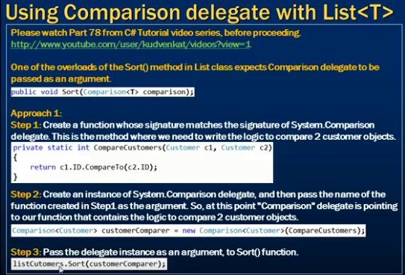

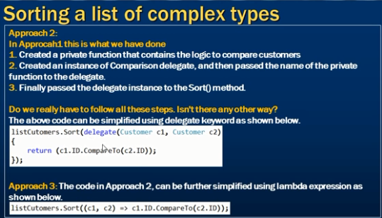

**Useful Methods in List:**

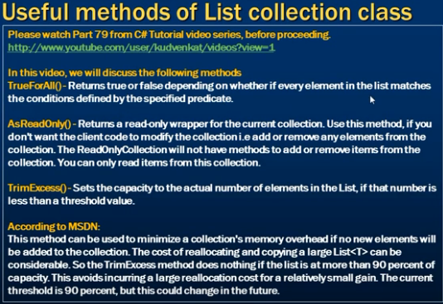

//List Useful methods

using System;

using System.Collections.Generic; // For list

using System.Collections.ObjectModel; // For AsReadOnly() method

class Program

{

static void Main(string[] args)

{

Customer Customer1 = new Customer()

{ id = 1, name = "kumar", age = 27, salary = 20000 };

Customer Customer2 = new Customer()

{ id = 2, name = "suresh", age = 28, salary = 10000 };

Customer Customer3 = new Customer()

{ id = 3, name = "rajesh", age = 26, salary = 50000 };

List<Customer> Customers = new List<Customer>(100);

Customers.Add(Customer1);

Customers.Add(Customer2);

Customers.Add(Customer3);

//Method4: TrimExcess() changes the capacity of list to max values contained list.

Console.WriteLine("Before Capacity: "+ Customers.Capacity); //o/p: Before Capacity: 100

Customers.TrimExcess();

Console.WriteLine("After Capacity: " + Customers.Capacity); //o/:p After Capacity: 3

//Method1: TrueForAll() it returns boolean value (true or false)

Console.WriteLine("Are all salaries greter than 5000 {0}" , Customers.TrueForAll(X => X.salary > 5000));

//o/p: true

//Method2: AsReadOnly() we can’t add or remove data to collection but we can retrive data

ReadOnlyCollection<Customer> Reaonlycollection = Customers.AsReadOnly();

// Reaonlycollection.(Add); //compile error

// Console.WriteLine(Reaonlycollection[1]);

Console.WriteLine( "items- " + Reaonlycollection.Count); // o/p:items- 3

}

}

public class Customer

{

public int id { get; set; }

public string name { get; set; }

public int age { get; set; }

public int salary { get; set; }

}

**Optional parameters:**

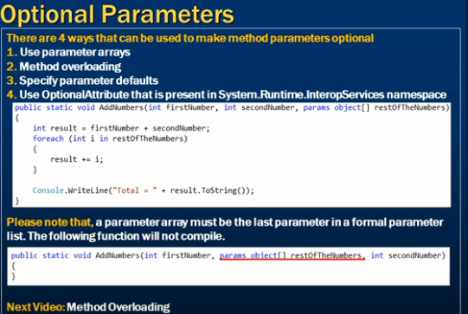

// Optional parameters

/// method 1- using parameterArray

using System;

using System.Collections.Generic; // For list

using System.Collections.ObjectModel; // For AsReadOnly() method

class Program

{

static void Main(string[] args)

{

// AddNumbers(10, 20); // 30

// AddNumbers(10, 20,40); //output: 70

AddNumbers(10, 20,new object[]{ 30,40,50}); //output: 150

}

public static void AddNumbers(int A,int B, params object[] restofvalues) // 'params object[] restofvalues ' must be last parameter

{

int sum = A + B;

if (restofvalues != null) {

foreach (int i in restofvalues) {

sum += i;

}

}

Console.WriteLine(sum);

}

}

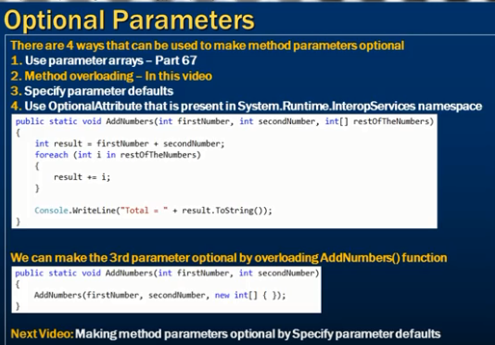

// Optional parameters

/// method 2- using methodoverloading

using System;

using System.Collections.Generic; // For list

using System.Collections.ObjectModel; // For AsReadOnly() method

class Program

{

static void Main(string[] args)

{

//AddNumbers(10, 20); // output: 30

AddNumbers(10, 20,new int[] { 20, 30, 40 }); // output: 120

}

/// methodoverloading here

public static void AddNumbers(int A, int B)

{

AddNumbers(A, B, null);

}

public static void AddNumbers(int A,int B, int[] restofvalues)

{

int sum = A + B;

if (restofvalues != null) {

foreach (int i in restofvalues) {

sum += i;

}

}

Console.WriteLine(sum);

}

}

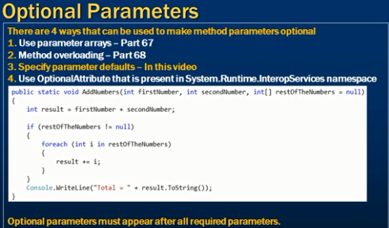

// Optional parameters

/// method 3- by specifying parameter defaults

using System;

using System.Collections.Generic; // For list

using System.Collections.ObjectModel; // For AsReadOnly() method

class Program

{

static void Main(string[] args)

{

//AddNumbers(10, 20); // output: 30

AddNumbers(10, 20,new int[] { 20, 30, 40 }); // output: 120

}

public static void AddNumbers(int A,int B, int[] restofvalues=null)

{

int sum = A + B;

if (restofvalues != null) {

foreach (int i in restofvalues) {

sum += i;

}

}

Console.WriteLine(sum);

}

}

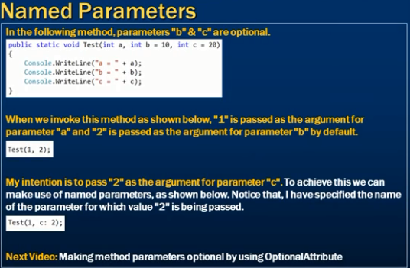

// Optional parameters

/// method 3- named parameters

using System;

using System.Collections.Generic; // For list

using System.Collections.ObjectModel; // For AsReadOnly() method

class Program

{

static void Main(string[] args)

{

// Test(10); //output: 60 (a=10,b=20,c=30)

//Test(10,15); //output: 55 (a=10,b=15,c=30)

// Test(10,15,25); //output: 50 (a=10,b=15,c=20)

Test(10, c:5); //output: 35 (a=10,b=20,c=5)

}

public static void Test(int a,int b=20,int c=30)

{

int sum = a + b + c;

Console.WriteLine(sum);

}

}

Making method parameters optional by using OptionalAttribute:

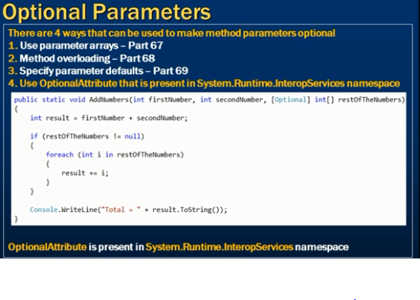

// Optional parameters

/// method 3- Making method parameters optional by using OptionalAttribute

using System;

using System.Collections.Generic;

using System.Runtime.InteropServices;

class Program

{

static void Main(string[] args)

{

//AddNumbers(10, 20); // output: 30

AddNumbers(10, 20, new int[] { 20, 30, 40 }); // output: 120

}

public static void AddNumbers(int A, int B, [Optional] int[] restofvalues)

{

int sum = A + B;

if (restofvalues != null)

{

foreach (int i in restofvalues)

{

sum += i;

}

}

Console.WriteLine(sum);

}

}

**Multithreading:**

/// Multithreading

using System;

using System.Threading; // All thread classes are avialable in this namespace

class Program

{

static void Main(string[] args)

{

//Numbers.PrintNums(); // Direct calling

/// Thread overload functions

/*

1. public Thread(ThreadStart start);

2. public Thread(ParameterizedThreadStart start);

3. public Thread(ThreadStart start, int maxStackSize);

4. public Thread(ParameterizedThreadStart start, int maxStackSize);

*/

/// method1

/// Creating a Thread

// Thread T1 = new Thread(new ThreadStart(Numbers.PrintNums)); // approach 1

// Thread T1 = new Thread(delegate() { Numbers.PrintNums(); }); // approach 2

// Thread T1 = new Thread(new ThreadStart(Numbers.PrintNums)); === Thread T1 = new Thread(Numbers.PrintNums);

/// it is called as thread delegate . delegate is a type safe function pointer

// Thread T1 = new Thread(Numbers.PrintNums);// approach 3

/// new ThreadStart() takes internally

Thread T1 = new Thread(()=> Numbers.PrintNums());// approach 4(lamda functions)

/// To start a Thread

T1.Start(); // o/p: 1 2 3 4 5 6 7 8 9 10

/// For nonStatic Function create instance

Numbers num1 = new Numbers();

Thread T2 = new Thread(num1.PrintNums1);

/// To start a Thread

T2.Start(); // o/p: 1 2 3 4 5 6 7 8 9 10

}

}

**ParameterizedThreadStart delegate:**

/// Multithreading

using System;

using System.Threading; // All thread classes are avialable in this namespace

class Program

{

static void Main(string[] args)

{

Console.WriteLine("Enter Target number");

object target =Console.ReadLine();

Thread T1 = new Thread(Numbers.Addnum);

T1.Start(target);

}

}

class Numbers

{

public static void Addnum(object target) {

int number=0;

if (int.TryParse(target.ToString(), out number))

{

for (int i = 0; i <= number; i++)

{

Console.WriteLine(i);

}

}

}

}

**Passing data to the Thread function in a type safe manner:**

using System;

using System.Threading;

namespace ThreadStartDelegateExample

{

class Program

{

public static void Main()

{

// Prompt the user for the target number

Console.WriteLine("Please enter the target number");

// Read from the console and store it in target variable

int target = Convert.ToInt32(Console.ReadLine());

// Create an instance of the Number class, passing it

// the target number that was read from the console

Number number = new Number(target);

// Specify the Thread function

Thread T1 = new Thread(new ThreadStart(number.PrintNumbers));

// Alternatively we can just use Thread class constructor as shown below

// Thread T1 = new Thread(number.PrintNumbers);

T1.Start();

}

}

// Number class also contains the data it needs to print the numbers

class Number

{

int _target;

// When an instance is created, the target number needs to be specified

public Number(int target)

{

// The targer number is then stored in the class private variable _target

this._target = target;

}

// Function prints the numbers from 1 to the traget number that the user provided

public void PrintNumbers()

{

for (int i = 1; i<= _target; i++)

{

Console.WriteLine(i);

}

}

}

}

**Retrieving data from Thread function using callback method:**

using System;

using System.Threading;

namespace ThreadStartDelegateExample

{

// Step 1: Create a callback delegate. The actual callback method

// signature should match with the signature of this delegate.

public delegate void SumOfNumbersCallback(int sumOfNumbers);

// Step 2: Create Number class to compute the sum of numbers and

// to call the callback method

class Number

{

// The traget number this class needs to compute the sum of numbers

int _target;

// Delegate to call when the the Thread function completes computing the sum of numbers

SumOfNumbersCallback _callbackMethod;

// Constructor to initialize the target number and the callback delegateinitialize

public Number(int target, SumOfNumbersCallback callbackMethod)

{

this._target = target;

this._callbackMethod = callbackMethod;

}

// This thread function computes the sum of numbers and then invokes

// the callback method passing it the sum of numbers

public void ComputeSumOfNumbers()

{

int sum = 0;

for (int i = 1; i[= _target; i++)

{

sum = sum + i;

}

if (_callbackMethod != null)

{

_callbackMethod(sum);

}

}

}

// Step 3: This class consumes the Number class created in Step 2

class Program

{

// Callback method that will receive the sum of numbers

public static void PrintSumOfNumbers(int sum)

{

Console.WriteLine("Sum of numbers is " + sum);

}

public static void Main()

{

// Prompt the user for the target number

Console.WriteLine("Please enter the target number");

// Read from the console and store it in target variable

int target = Convert.ToInt32(Console.ReadLine());

// Create an instance of callback delegate and to it's constructor

// pass the name of the callback function (PrintSumOfNumbers)

SumOfNumbersCallback callbackMethod = new SumOfNumbersCallback(PrintSumOfNumbers);

// Create an instance of Number class and to it's constrcutor pass the target

// number and the instance of callback delegate

Number number = new Number(target, callbackMethod);

// Create an instance of Thread class and specify the Thread function to invoke

Thread T1 = new Thread(new ThreadStart(number.ComputeSumOfNumbers));

T1.Start();

}

}

}